US Air Force’s GPS 2F Constellation Now Complete
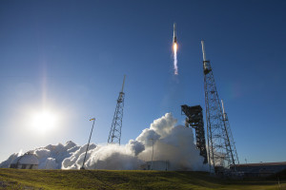
The Atlas 5 launch of GPS 2F-12. Photo: ULA
[Via Satellite 02-08-2016] The final satellite in the U.S. Air Force’s Global Positioning System 2F series, GPS 2F-12, launched Feb. 5 aboard an Atlas 5 rocket from United Launch Alliance (ULA), completing the constellation. The Boeing-built satellite entered its Medium Earth Orbit (MEO) position at around 12,000 miles, and had signal acquisition within four hours of lift off.
GPS 2F-12 is expected to be operational in approximately one month, following on-orbit tests. This is the 50th GPS satellite from Boeing to the Air Force. The GPS 2F series has improved the accuracy and security of the system while introducing new civilian, aeronautical and military capabilities.
Fuente: Satellite Today
URL: http://www.satellitetoday.com/regional/2016/02/08/us-air-forces-gps-2f-constellation-now-complete/?hq_e=el&hq_m=3210381&hq_l=10&hq_v=c046d22247

