ESA Awards Sentinel 3C and D Satellite Contracts to Thales Alenia Space
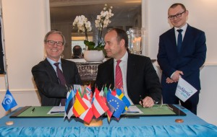
Sentinel 3C and 3D contract signature. Photo: ESA
[Via Satellite 02-10-2016] The European Space Agency (ESA) has awarded a $505 million contract to Thales Alenia Space for the design, development, integration and testing of the Sentinel 3C and D environmental monitoring and oceanographic satellites. The satellites will each be fitted with four instruments — two optical and two radar — to continue the Copernicus program. Copernicus aims to ensure European independence in the acquisition and management of Earth’s environmental data, to provide sound support for Europe’s authorities and decision-makers. The main objective of the Sentinel 3 mission is the global observation of oceans and land, including their “color” and temperature, along with a precise measurement of ocean heights. Each satellite, Sentinel 3C and 3D, will weigh approximately 1.2 metric tons at launch, and will be positioned in Low Earth Orbit (LEO) at an altitude of 815 kilometers.
ESA’s Sentinel programs include six families of satellites, each fitted with instruments for their specific missions. Sentinel 3 will ensure continuity with the optical observation data provided by Envisat. Sentinel 3A, scheduled for launch in mid-February, will mark the start of this operational service. Sentinel 3B is now being integrated at Thales Alenia Space’s plant in Cannes, southern France, and is scheduled for launch in mid-2017. Sentinel 3C and 3D are slated for launch from 2021, and are compatible with Arianespace’s light launcher Vega.
Fuente: Satellite Today
URL: http://www.satellitetoday.com/regional/2016/02/10/esa-awards-sentinel-3c-and-d-satellite-contracts-to-thales-alenia-space/?hq_e=el&hq_m=3211543&hq_l=7&hq_v=c046d22247

